PROJECT DESIGN PHASE – 1

**SOLUTION ARCHITECTURE**

|  |  |
| --- | --- |
| Date | 2nd October 2022 |
| Team ID | PNT2022TMID18166 |
| Project Name | Analytics for Hospital Health-Care Data |
| Maximum Marks | 2 Marks |

SYSTEM ARCHITECTURE:

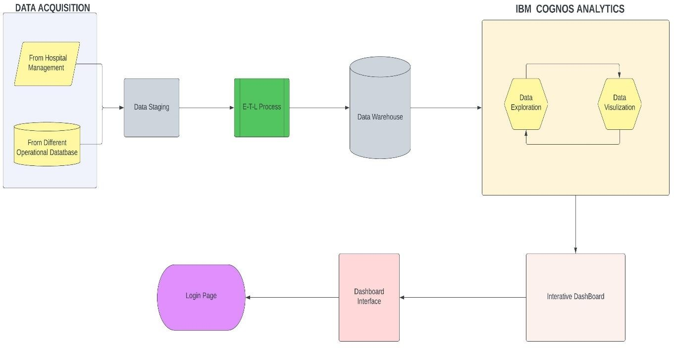

ETL PROCESS (DATA INTEGRATION PROCESS):

